Shoe Sizes Example

Sean van der Merwe

08/03/2022

## Introduction

For this example we will start with a simple sample of shoe sizes and try to build a predictive model of shoe sizes for people similar to the ones sampled.

"Shoes.xlsx" |> openxlsx::read.xlsx() -> ShoesData  
y <- ShoesData$ShoeSize  
x <- ShoesData$Gender  
table(y)

## y  
## 3 4 5 6 7 8 10 10.5 13   
## 1 1 1 4 4 1 1 1 1

## Model

Shoe sizes only come in half sizes, so if we double the sizes we end up with positive whole numbers. So we could use a model for whole numbers, like the Negative Binomial or Discrete Weibull for the double sizes. If we are interested in predicting shoe sales then this model would make a lot of sense.

Alternatively, we could think about the data generating process and realise that shoes go on feet and feet sizes are positive real numbers. People might wear shoes in the closest size to their feet. We could consider the observations as rounded real numbers, or censored, or measured with errors of a certain type.

For today’s example we will use a LogNormal distribution.

### Prior

$$μ∼N\left(1.95,σ=0.15\right) , σ∼Gamma\left(0.001,0.001\right)$$

## Stan model

data {  
 int n;  
 real y[n];  
}  
parameters {  
 real mu;  
 real<lower=0> sigma;  
}  
model {  
 y ~ normal(mu, sigma);  
 mu ~ normal(1.95, 0.15);  
 sigma ~ gamma(0.001, 0.001);  
}

#### Run Stan

logSizes <- log(ShoesData$ShoeSize)  
library(rstan)  
shoes1 |> sampling(data = list(y = logSizes, n = length(logSizes))) -> output

output |> traceplot()

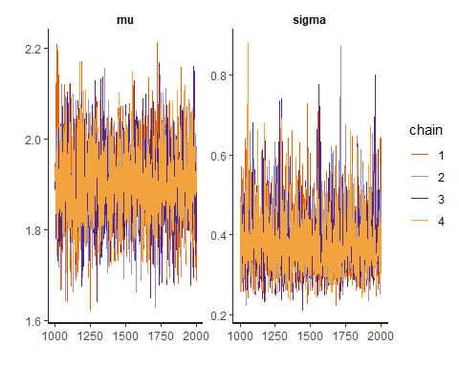

output |> extract() -> post_sims  
(output |> summary())$summary |> knitr::kable(digits = 3)

|  | mean | se_mean | sd | 2.5% | 25% | 50% | 75% | 97.5% | n_eff | Rhat |
| --- | --- | --- | --- | --- | --- | --- | --- | --- | --- | --- |
| mu | 1.905 | 0.002 | 0.083 | 1.739 | 1.850 | 1.904 | 1.961 | 2.071 | 2392.455 | 1.000 |
| sigma | 0.383 | 0.002 | 0.078 | 0.267 | 0.329 | 0.371 | 0.423 | 0.573 | 2132.323 | 1.001 |
| lp__ | 6.960 | 0.027 | 1.045 | 4.052 | 6.552 | 7.283 | 7.703 | 7.970 | 1527.975 | 1.002 |

## Posterior

post_sims$mu |> hist()

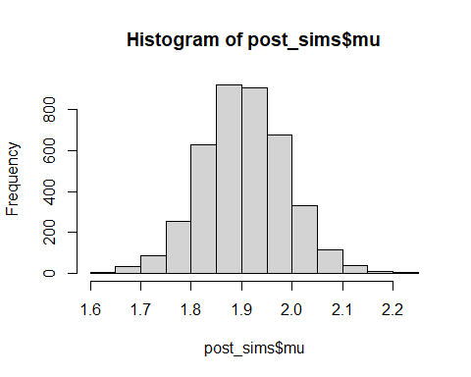

plot(post_sims$mu, post_sims$sigma)

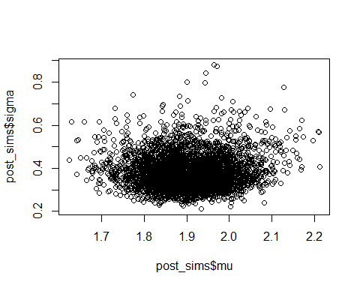

(mu_hat <- mean(post_sims$mu))

## [1] 1.905407

## Predictive

nsims <- length(post_sims$mu)  
pred_sims <- exp(rnorm(nsims, post_sims$mu, post_sims$sigma))

pred_sims |> density() |> plot(main ='', lwd=3, col='purple')

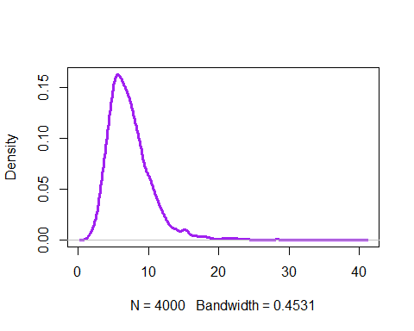

Probability of a shoe size about 15 given our sample?

mean(pred_sims > 15)

## [1] 0.02725