Bayes Class 1 challenge

Sean van der Merwe

15/02/2022

# Introduction

I want to open boxes until I get 2 E’s, 1 F, and 1 G from:

| Item | A | B | C | D | E | F | G | H | I |
| --- | --- | --- | --- | --- | --- | --- | --- | --- | --- |
| Prob | 0.3 | 0.2 | 0.15 | 0.1 | 0.1 | 0.05 | 0.04 | 0.03 | 0.02 |

# Implementation

1. Enter the data
2. Draw random items until I get my set
3. Count how many items I drew
4. Repeat 2 and 3 and store results

probs <- c(0.3,0.2,0.15,0.1,0.1,0.05,0.04,0.03,0.02)  
items <- LETTERS[1:9]

count_func <- function() {  
count <- 0  
tbl <- rep(0, 9)  
while ((tbl[5]<2) | (tbl[6]<1) | (tbl[7]<1)) {  
# while (!((tbl[5]>=2) & (tbl[6]>=1) & (tbl[7]>=1)))  
 draw <- sample(1:9, 1, replace = T, prob = probs)  
 count <- count + 1  
 tbl[draw] <- tbl[draw] + 1   
}  
count  
}

replicate(10000, count_func()) -> dist

dist |> density() |> plot(main='', lwd = 2, col = 'purple')

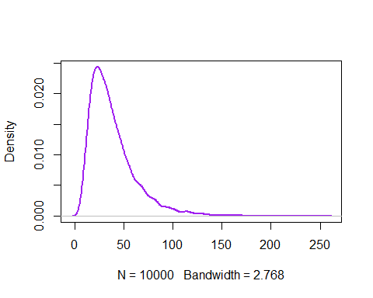

dist |> mean()

## [1] 38.3583

dist |> quantile(0.95)

## 95%   
## 83