Bayes Class 2

Sean van der Merwe

22/02/2022

# Bayes’ Theorem

$$p\left(θ|x\right)∝like\left(x|θ\right)p\left(θ\right)$$

$$\text{log}p\left(θ|x\right)=ℓ\left(x|θ\right)+\text{log}p\left(θ\right)+c_{1}$$

$$ℓ=5n\text{log}λ−λ\sum_{i=1}^{n}{x_{i}}+c_{2}$$

$$\text{log}p\left(λ|x\right)=5n\text{log}λ−λ\sum_{i=1}^{n}{x_{i}}−0.5\text{log}λ−0.5λ+c_{3}$$

$$\text{log}p\left(λ|x\right)=\left(5n−0.5\right)\text{log}λ−λ\left(\sum_{i=1}^{n}{x_{i}}+0.5\right)+c_{3}$$

$$λ|x∼Gamma\left(5n+0.5,∑x_{i}+0.5\right)$$

x <- c(7, 15, 5, 11, 14, 10, 20, 10, 4)  
n <- length(x)

nsims <- 10000  
lambda_sims <- rgamma(nsims, 5*n+0.5, sum(x) + 0.5)

lambda_sims |> density() |> plot()

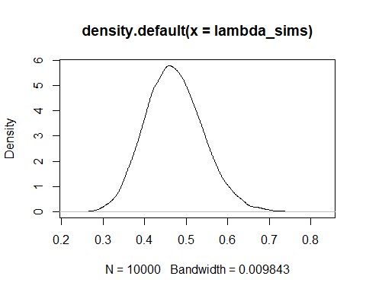

rgamma(nsims, 5, lambda_sims) -> pred_x

hist(pred_x)

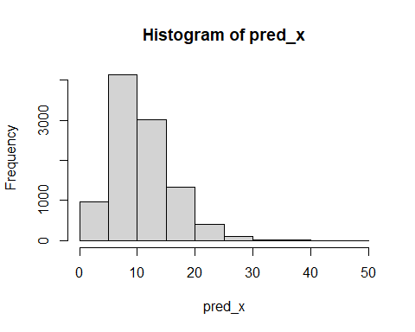

What is the probability of waiting more than 15 minutes?

mean(pred_x>15)

## [1] 0.1893

What is the probability that the longest wait of a random sample of 10 people is longer than 15 minutes?

lambda_sims |> sapply(\(l) {  
 rgamma(10, 5, l) |> max()  
}) -> maximums  
mean(maximums > 15)

## [1] 0.7935

mean(pred_x)

## [1] 10.8037

quantile(pred_x, c(0.025, 0.975))

## 2.5% 97.5%   
## 3.354633 22.783662